[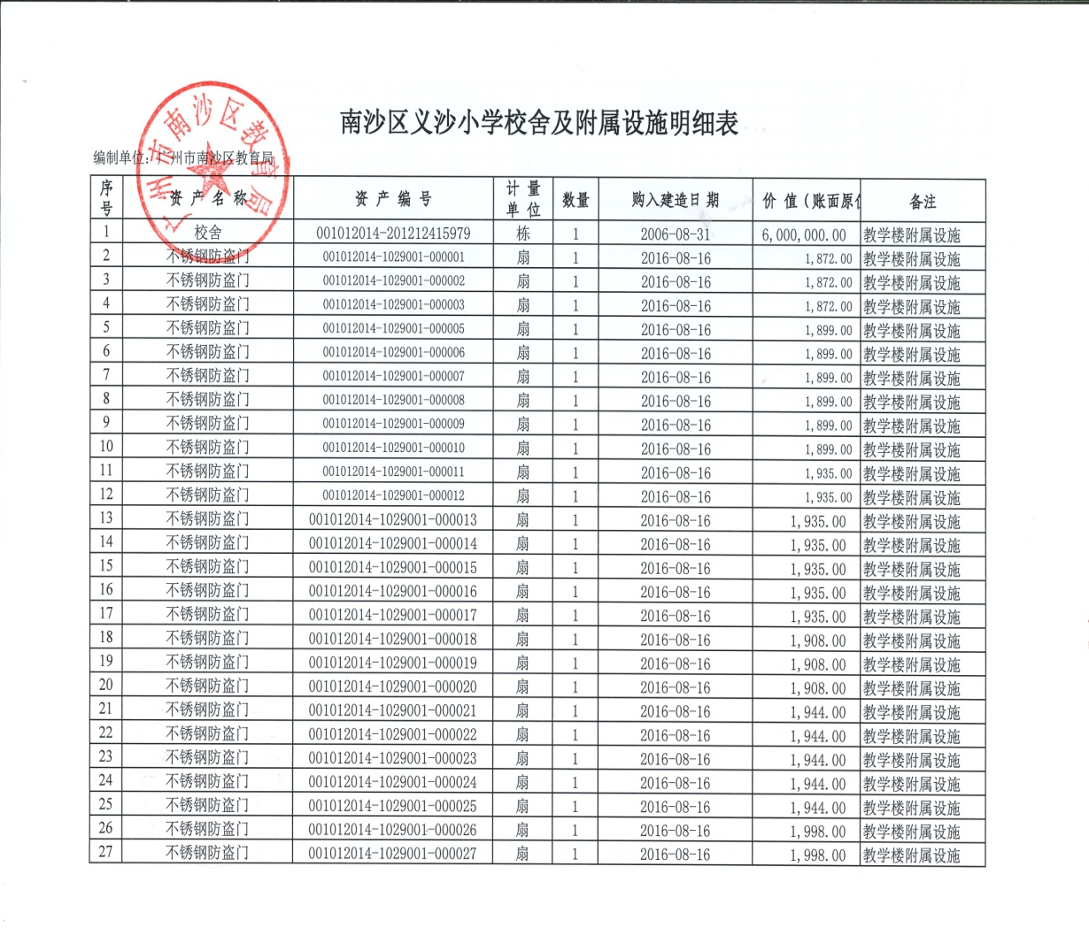](http://172.29.0.222:9000/webpic/W0201809/W020180910/W020180910637814240854.jpg)

[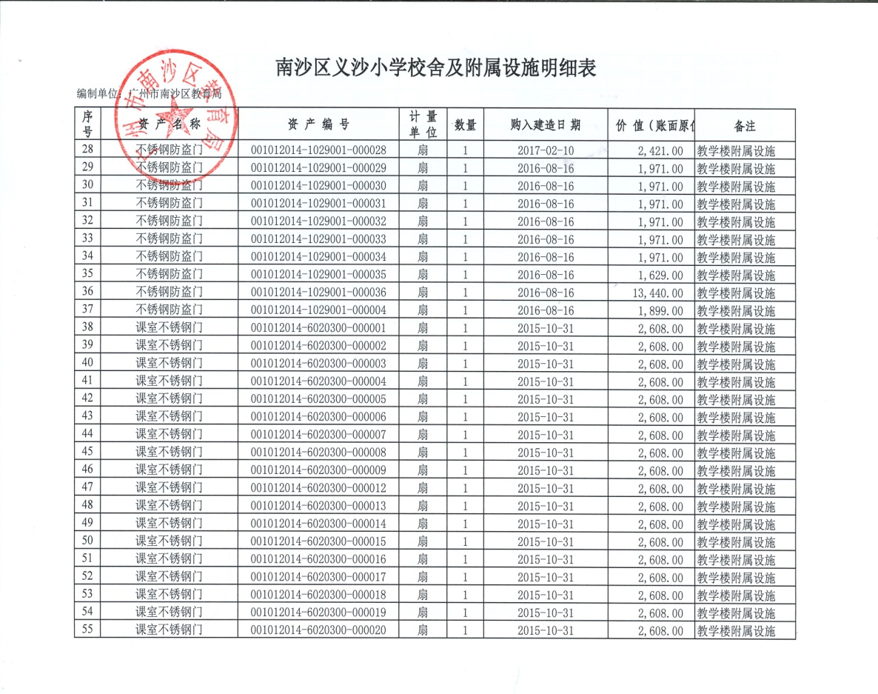](http://172.29.0.222:9000/webpic/W0201809/W020180910/W020180910637814286383.jpg)

[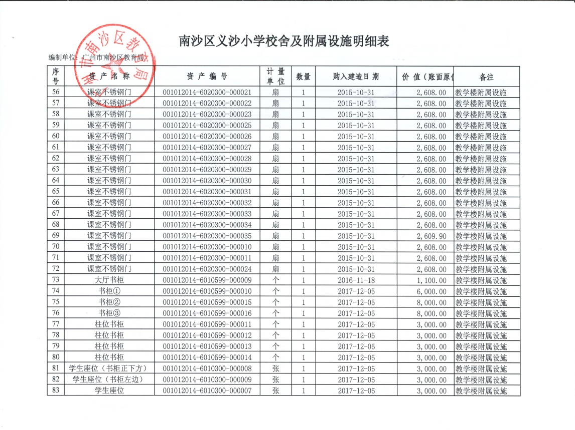](http://172.29.0.222:9000/webpic/W0201809/W020180910/W020180910637814326168.jpg)

[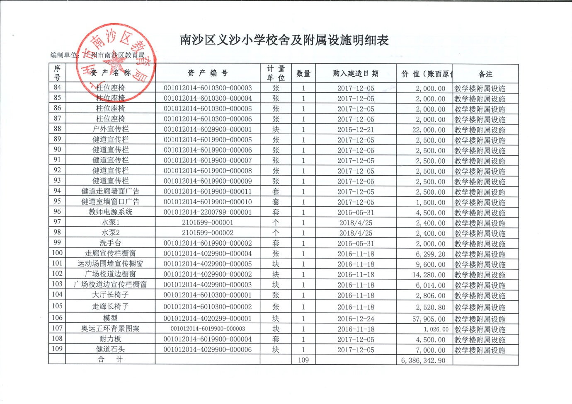](http://172.29.0.222:9000/webpic/W0201809/W020180910/W020180910637814355778.jpg)